CS Practical Assignments

Kendriya Vidyalaya Sector-5, Dwarka

Kunal Kumar, 21

12 A

# Practical – 1

## Aim:

Write a python program to search first occurrence of an element in

a list by using Linear search and display frequency of each element

present in list. (List and search element should be entered by user)

## Solution:

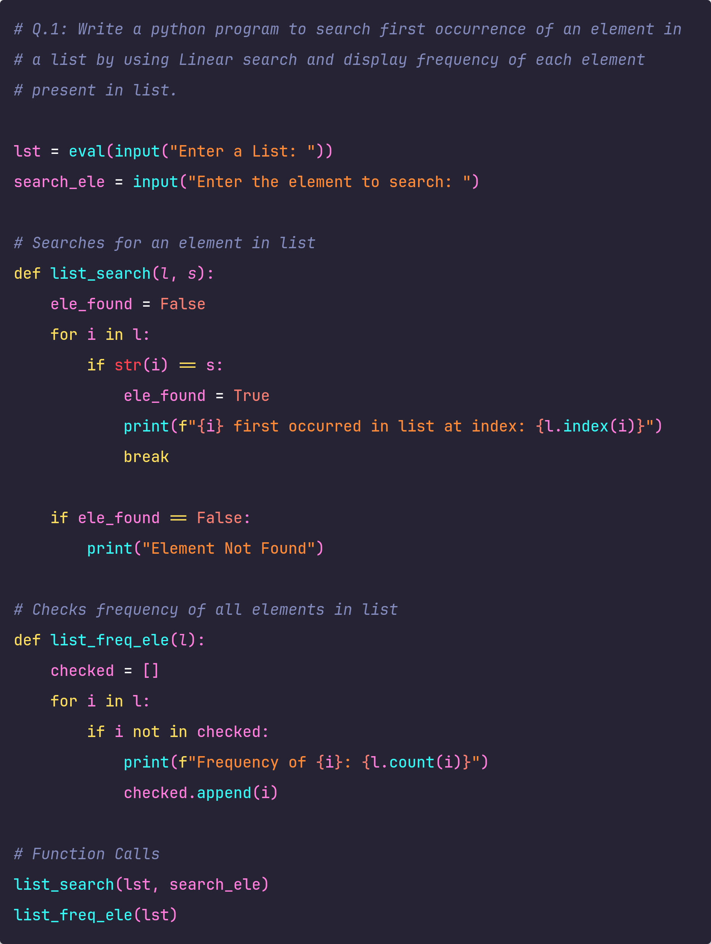

## Output:

